Order Of Service

Singing: Psalm 6—CW page 66

Reading: Psalm 68:1-18

Opening Hymn: CW 260

Reading: Acts 8:4-13

Request Hymn: CW Supplement 749

Reading: John 17

Sermon Hymn: CW 363

Sermon Text: Daniel 2:31-35

The Mysterious Dream

Prayer

The Apostles’ Creed, TLH page 12

Holy Communion

The Lord's Prayer

The Blessing

Closing Hymn: CW 449

* * * * * * * * * * *

Bible Study: Lambs: Dog
Sheep: Romans 8:28-32
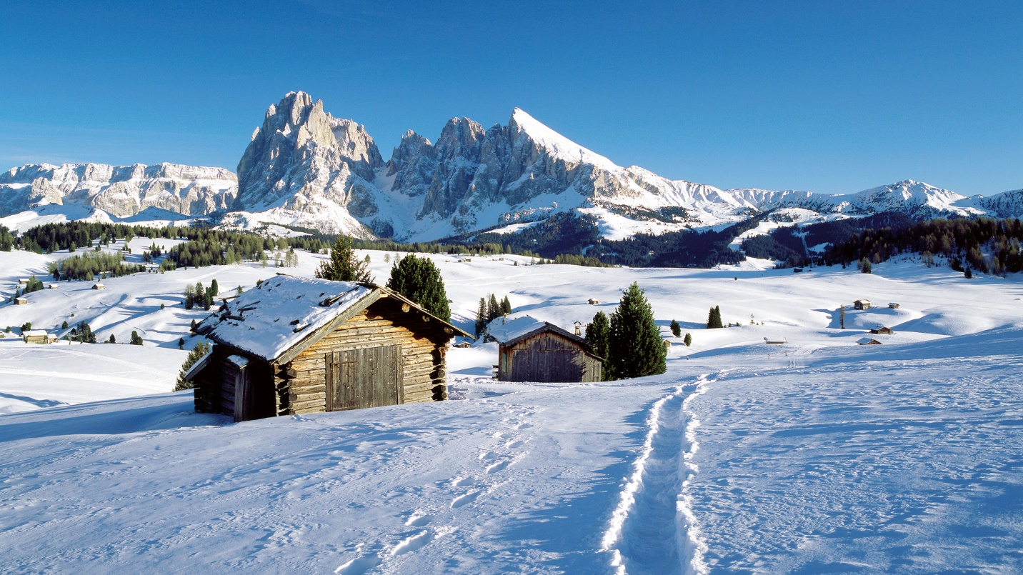

Winter Wonderland

Water
Of
Life

21 January 2018

W A T E R O F L I F E

Independent Christian Church—Conservative Lutheran Doctrine

Worship Service: 9:30 a.m. Bible Study: 10:45 a.m.

Larry Cooper, Pastor E-Mail address:
111 N. Ridge Road lcooper@wateroflife.cc
Coon Valley, WI 54623 Web Site:
Phone: (608) 452-2105 www.wateroflife.cc

* * * * * * * * * * * * * * * * * * * * * * * * * * *

Sermon Text: Daniel 2:31-35

The Mysterious Dream

* * * * * * * * * * * * * * * * * * * * * * * * * * *

Daniel 2:31 Thou, O king, sawest, and behold a great image. This great image, whose brightness was excellent, stood before thee; and the form thereof was terrible.
:32 This image's head was of fine gold, his breast and his arms of silver, his belly and his thighs of brass,
:33 His legs of iron, his feet part of iron and part of clay.
:34 Thou sawest till that a stone was cut out without hands, which smote the image upon his feet that were of iron and clay, and brake them to pieces.
:35 Then was the iron, the clay, the brass, the silver, and the gold, broken to pieces together, and became like the chaff of the summer threshingfloors; and the wind carried them away, that no place was found for them: and the stone that smote the image became a great mountain, and filled the whole earth.

